VPN SET UP PROCEDURE
- Go to the url https://skyeremoteaccess.skyebankng.com
- 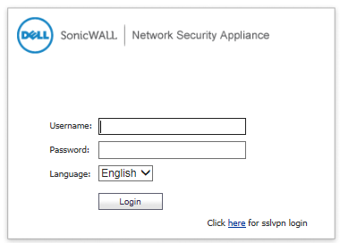
- Click the option at the right bottom corner “Click here for sslvpn login”
- 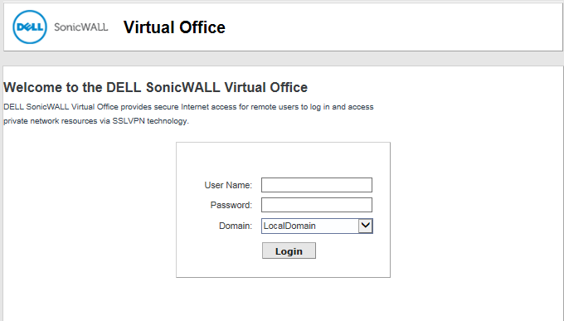
- At this stage, enter the username and password.
- Change the password, if you are prompted to do so.
- Login again with the username and the new password.
- The page below comes up

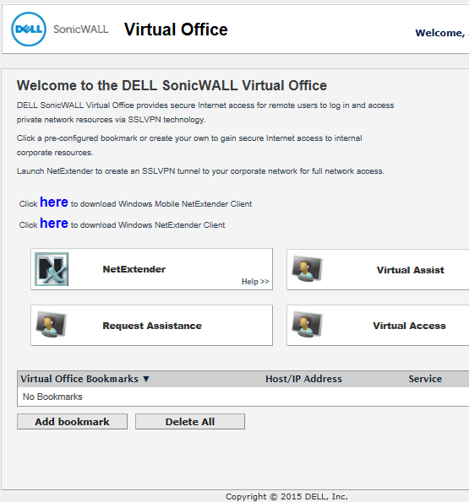
- Click option 2, NETEXTENDER “Click here to download Windows NetExtender Client”
- Run the application
- Launch the application on the desktop and fill the parameters:
Server: skyeremoteaccess.skyebankng.com:4433
Domain: LocalDomain

